**Tasks**

**Learners have to develop a dashboard to support the answers to the following questions.**

**Objective Questions**:

1. **What is the total no. of tables present in the data?**

Ans. Only one table is present in the dataset for analysis.

1. **What is the total no. of attributes present in the data?**

Ans. There are a total of 35 attributes in the datasheet to be cleansed and analyzed.

1. **The data consists of some inconsistent and missing values so ensure that the data used for further analysis is cleaned.**

Ans. Hid a few irrelevant columns:- time-duration(some irrelevant data as per the description provided in the presentation), isWhiteListUser and queue columns are ir-relevant (they have single values)

Did some cleaning and extraction over the following columns. **createdAT, updatedAt, chatStartTime and chatEndTime**

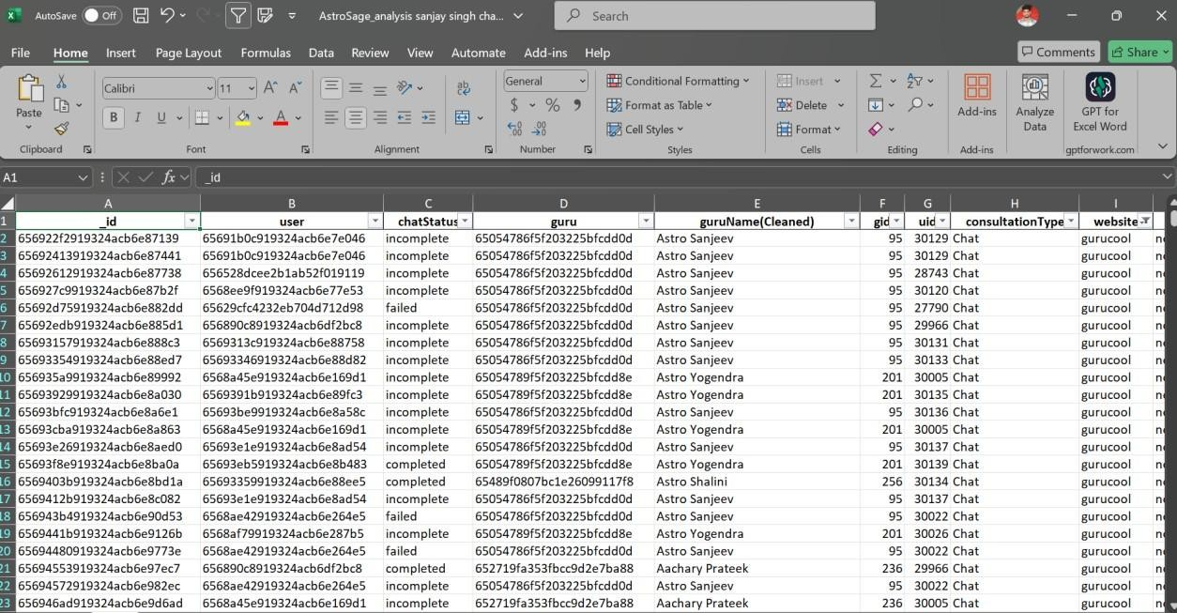

1. **What is the average daily call volume over the day by day and what’s the change on it?**

**Answer.**

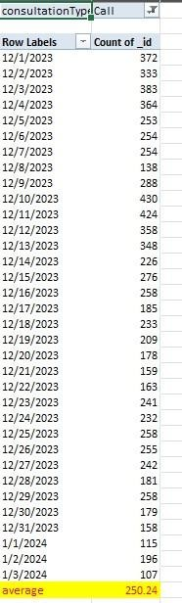

Average call per day = 250

The given pivot table in the sheet named ‘Calculations and Pivots” of the spreadsheet file summarizes the Daily call volume by grouping the days and counting the number of calls for each day.

Key insights drawn:

The data for daily calls received seems to be decreasing in the longer term and hence the stakeholders need to do something to prevent the daily call volume from impacting the revenue.

Suggestion:

Reason behind the decrease in call volume could be less number of new users and less retention rate(although this requires more analysis). A solution for this could be to increase spend in marketing and improvement of services.

1. Which months experienced the highest and lowest call volumes?

Ans.

|  |  |
| --- | --- |
| **Row Labels** | **Count of userCallStatus** |

Jan 234 Dec 5379

January has the highest call volumes and December has lowest call volumes.

Data for same is represented by the second column of the pivot table and can be seen only by applying the following filter to the dashboard:

● Set consultation type => call only

1. **What is the total operational cost for that month?**

Ans. Refer to the Sheet 1

|  |  |
| --- | --- |
| **Row Labels** | **Sum of netAmount** |

Jan 11772.69

Dec 202214.6253

1. **What is the average number of calls handled per agent per day?**

The Average call handled per agent per day comes out to be 1.91

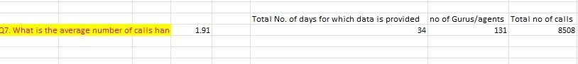

This was calculated by extracting the number of days, gurus/agents and total calls. For calculations:

Total calls/(no. of days * no of Gurus) = Average call handled per agent per day

**Inference From the Data**

An average call per day per agent of 1.91 seems to be very low and it may depict less user base or lower traffic received. This, coupled with the decreasing daily call volume could point to some serious problem within the business and the continuation of the same trend will be disastrous for the business.

1. **How many repeat callers are there, and what percentage of total calls do they represent?**

Ans. There are a total of 1275 repeat callers. And percentage is 56.62%

Steps taken to calculate this :

● Grouped the data of userId in a pivot table and added userId(count) to get the number of calls made by each user. calculated the total no of callers.

1. What is the total sales generated by the call center for each product category?

The given chart provides the required information regarding the sales generated for each product category.

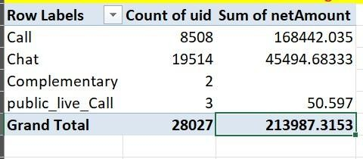

1. How many calls were made for each user ID and guru ID?

Answer: Drag User ID to Rows to group by users.

Drag Guru ID to Rows, beneath User ID, to show calls by guru for each user.

Then count Of Uid.

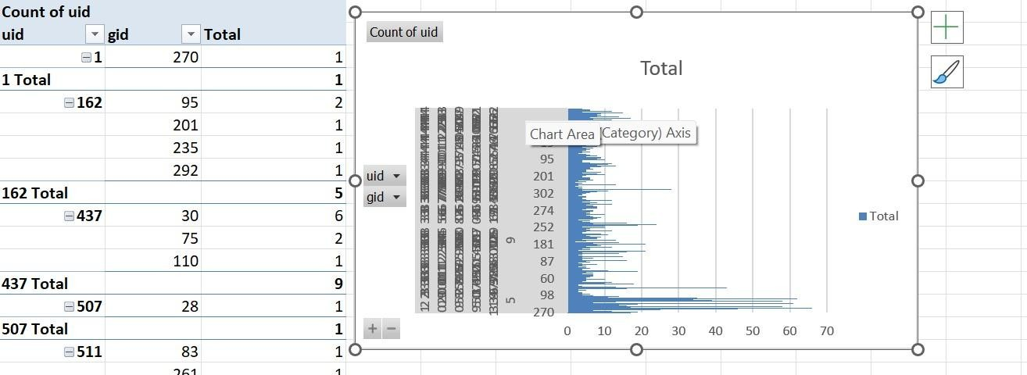

1. **What is the correlation between call duration and customer satisfaction?**

Answer.

**correlation**

-0.000202451

As a proper column for customer satisfaction was not available therefore considered rating as a metric to assess customer satisfaction and used that for calculation. Formula used : CORREL(Range of UserOnCallDuration, Range of Ratings)

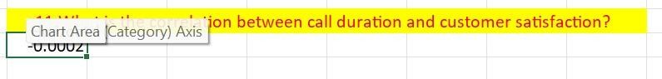

A correlation of -0.02 suggests a very weak negative correlation between the two variables being analyzed. This means:

* + **Direction:** As one variable increases, the other variable tends to decrease very slightly. However, this relationship is so weak that it's almost negligible.
  + **Strength:** The correlation is very close to 0, which indicates that the two variables are essentially independent of each other. Any observed trend is likely due to random chance rather than a meaningful relationship.

In practical terms, this correlation coefficient implies that knowing the value of one variable provides very little information about the likely value of the other variable.

**Key takeaway:** The two variables are almost unrelated.

**12. Which guru have the highest and lowest customer satisfaction scores?**

Ans

|  |
| --- |
| Highest Customer satisfation score Lowest customer satisfaction score |

7.5 Astro Pujaa Rai 0 Tarot Rittika

=MAX(M8:M149)

=MIN(M8:M149)

=XLOOKUP(Q8,M8:M149,L8:L149)

=XLOOKUP(Q9,M8:M149,L8:L149)

Used appropriate function to look for gid corresponding to max and min average rating. Function used: Max, min and Xlookup

* + 1. What is the average customer satisfaction score by month?

Answer:

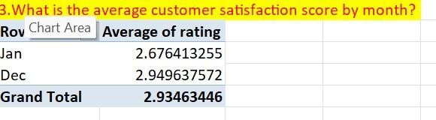

* + 1. How many categorical columns are there in the data? [Search about categorical and continuous data, and try to answer this question] Ans. 15

chatStatus, consultationType, website, refundStatus, isWhiteListUser, queue,

freeCall, freeChat, callChannel, callIvrType, callStatus, astrologerCallStatus, region, userCallStatus, rating

**Subjective Question:**

**1.** Should the investment be used to hire more agents, improve training programs, or upgrade call center technology?

Answer.

Approach used: For hiring more agents, analyze the average ratings of each guru (using gid).

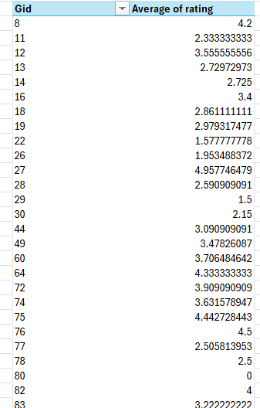

For improving training programs, we can calculate the average call time and average rating for each guru using the pivot table

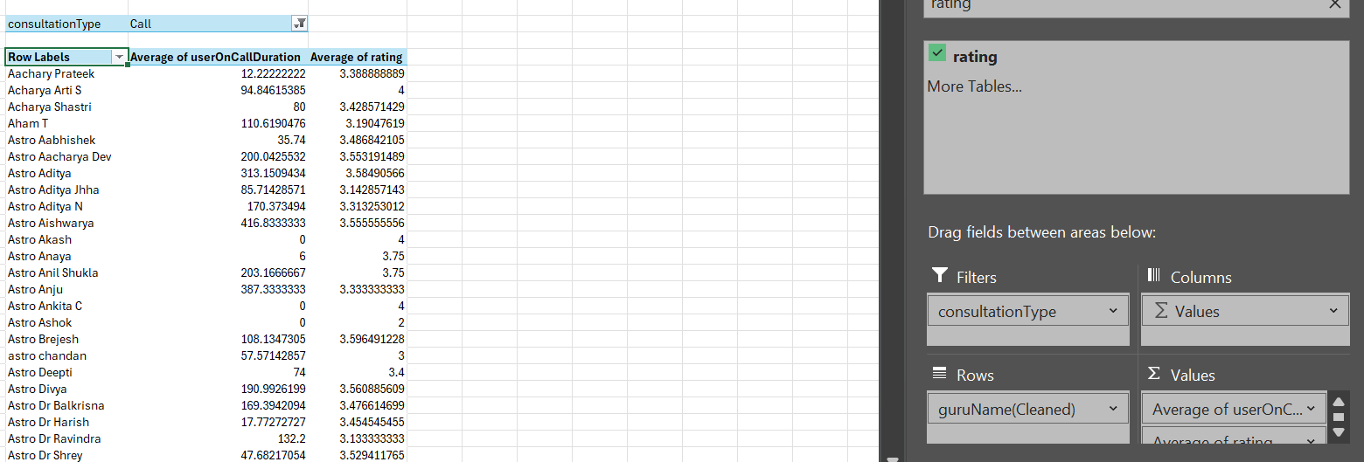

And for upgrading the call center technology, we can compare the call and chat statuses using pie chart which I have presented below

**5535**

**7256**

**6641**

**48**

**35**

**CHAT STATUS**

completed

failed

incomplete

pending

started



**call status**



busy



canceled



completed



failed



no-answer

***Suggestion*:** A portion of the investment received should be used for the following:

* + The technology of the Call Center should be optimized to distribute the volume in a uniform manner such that there is proper utilization of the workforce.
  + Focus on improving customer interactions by providing targeted training for agents and possibly enhancing call center technology to resolve issues that lead to poor customer experiences.

**2. What are the potential risks of each investment option (hiring, training, technology upgrades), and how can they be mitigated? Name the chart/spreadsheet function you will use for solving the problem?**

Answer:

Potential Risks For Technological Upgradation:

* 1. **Implementation Challenges**: New technology can be time to implement, and there may be unforeseen technical issues that might delay or complicate the transition.
  2. **High Upfront Costs**: Technology upgrades often require significant upfront investment, which may not yield immediate returns.

Mitigation Strategies:

* 1. **Phased Rollout**: Implementing technology upgrades in a phased manner in order to test their impact and work out any technical issues before a full-scale rollout. Start with smaller teams and gradually expand.
  2. **Cost-Benefit Analysis**: Performing a thorough cost-benefit analysis inorder to ensure that the technology investment aligns with expected improvements in efficiency and profitability.

Potential Risks with agent training:

* 1. **High Costs**: Extensive training programs can be expensive, both in terms of direct costs and lost productivity during training sessions.
  2. **Retention Issues**: There is a risk that agents who receive training may leave the company for better opportunities, leading to a loss of investment in their development.

Mitigation Strategies:

* 1. **Measure Training Effectiveness**: Implement performance tracking before and after training sessions to evaluate their effectiveness. Continuously refine the programs based on measurable outcomes.
  2. **Retention Programs**: Create retention incentives such as performancebased bonuses or career development opportunities to encourage trained agents to stay with the company.

Functions that can be utilized in order to facilitate the improvement are:

* + **Function:** WHATIF or Goal Seek
  + **Use:** Determine how the outcome is to changes in key inputs, such as the number of agents hired/trained or the cost of technology upgrades.Goal Seek can help determine the breakeven point for investments which can be a crucial data for analysis.

Visualization Tools:

* + **Function:** CHARTS (e.g., Bar Charts, Pie Charts, Waterfall Charts)
  + **Use:** Visualize the distribution of risks, costs, and potential returns. Charts like Waterfall charts can illustrate the incremental impact of each investment decision.

**Q3.How does AstroSage call center performance compare to that of AstroGuru in terms of average call volume, customer satisfaction, and agent performance?**

Will you use any aggregation function or a visualization here to solve the problem?

**Answer**. Data for AstroGuru is not provided for the analysis.

**Q4.How can the call center improve its handling of peak call periods to ensure high customer satisfaction?**

Mention the functionality which you will use for giving the suggestions, will it be any aggregate function or a visualization?

**Answer. Approach –**

We will calculate the average number of calls during each hour

For finding it we will create a pivot table

With consultation type as filter to call and updated hour in rows and uid in values as average

Suggestions:

Flexible Staffing: Use part-time, on-demand, or freelance agents who can be called in during peak times. Having a reserve pool of trained agents will help balance the workload without increasing permanent staffing costs.

Shift Optimization: Optimize agent shifts to peak periods accordingly. Ensure that more agents are scheduled during the high-traffic times.

Process of analysis:

* Extracting the hours from the date of creation by utilizing Right and Left functions.

* Calculating the average of hourly traffic/volume.

* 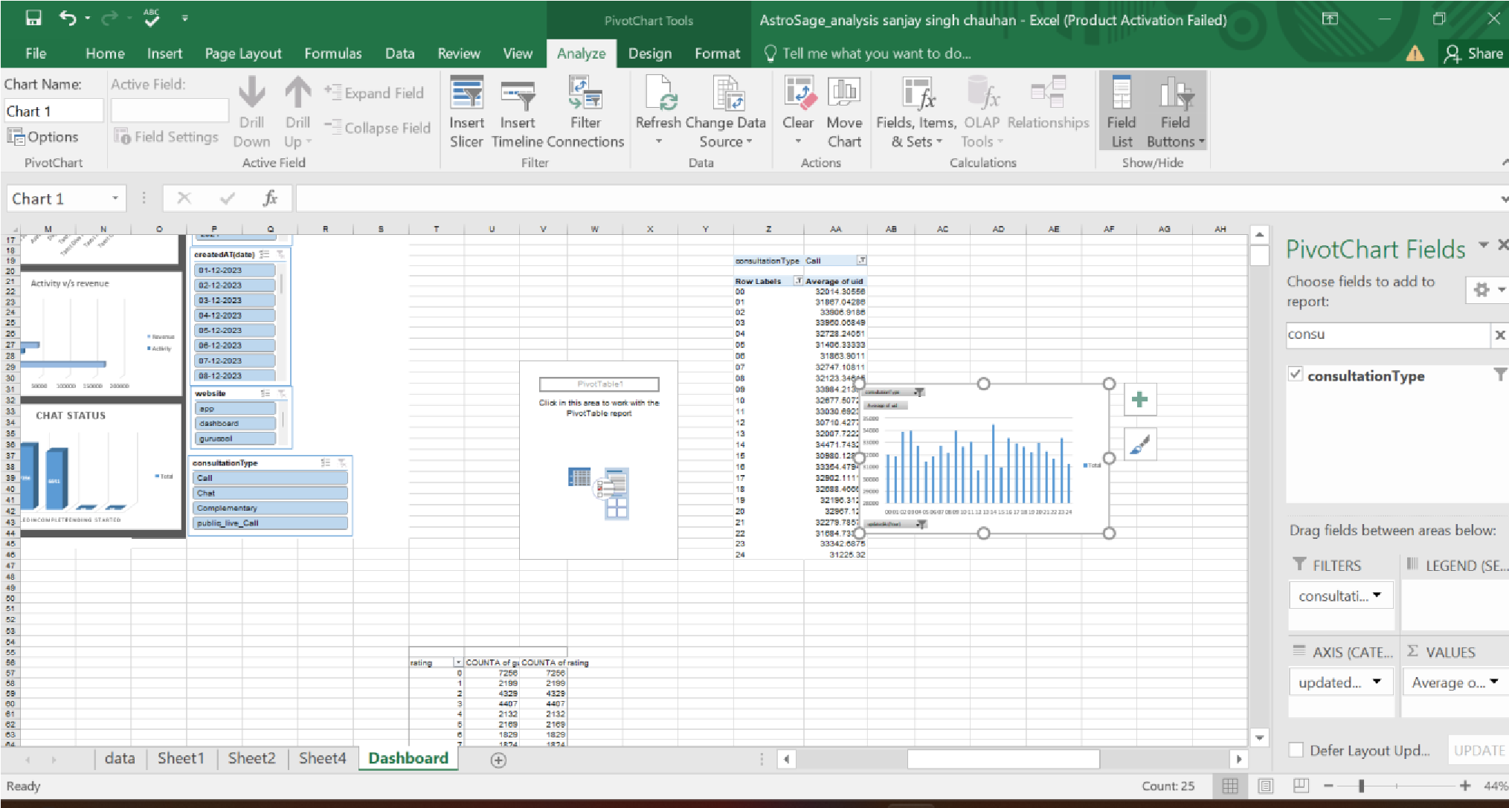Creating a chart to visualize the hourly traffic.

**Q5**.Based on historical data, what strategic initiatives should be prioritized to improve overall efficiency and customer satisfaction?

**Answer**:

Based on historical call center data and the goal of improving overall efficiency and customer satisfaction, the following strategic initiatives should be prioritized:

1. Selected Training for Poor Performing Agents

Analyzing the historical data, it will be seen that there are some agents whose failure rates are very high, and the customers’ ratings are also poor. There is much that targeted training can do to enhance their performance, decrease call failure rate, and increase customers’ satisfaction. Action :

Find the agents with low ratings and agents with many failures. Create effective training sessions based on the employees’ need for improvement in such areas as communication skills, problem-solving skills, and technical knowledge. It is necessary to assess changes in performance after training so that it is possible to determine whether the training was beneficial.

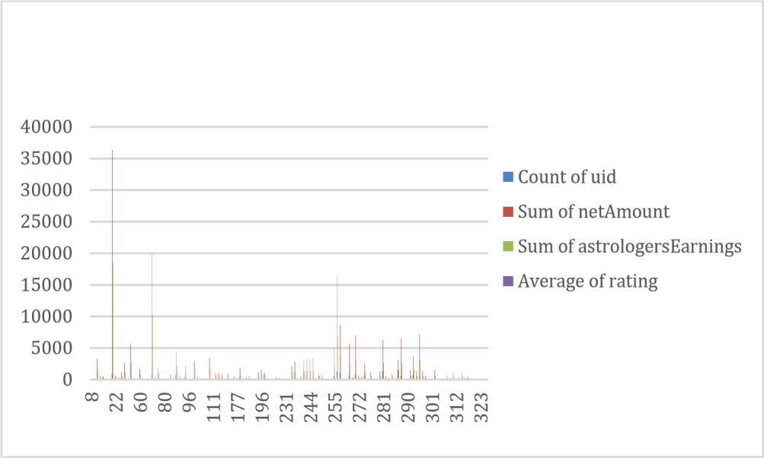

Given picture shows the distribution of Rating across the Agents.

It can be seen that the majority of the data lies in the left half showcasing the lower satisfaction of the customers.

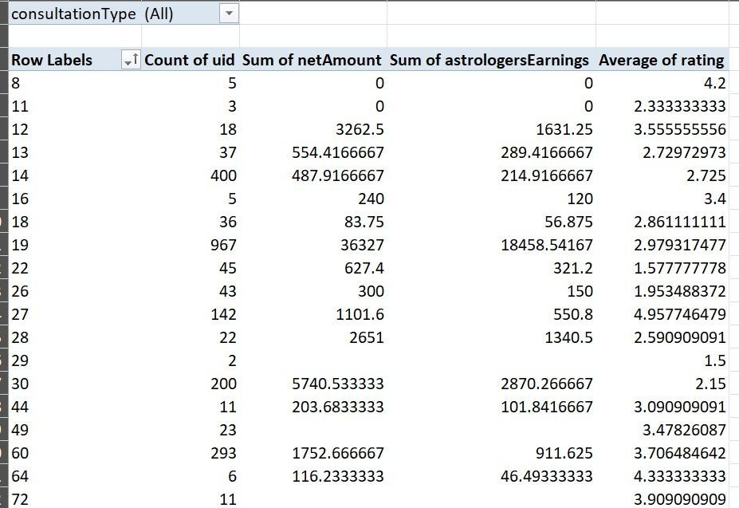

The rating distribution can be analysed through the above pivot table and appropriate actions like targeted training can be taken for special cases.

1. Improved Call Management and Call Priority

Poor call routing directs customers to stay longer on the line, become unhappy, and agents may be used inappropriately. There is a possibility of intelligent call routing systems to match the needs of the customers with the right agents.

Action:

Utilize skill-based routing that will help to route the calls to agents who will be in the right position to attend to the call.

Implement the concept of priority queuing so that valued or returning customers receive their services earlier, especially during the rush hour.

Deduce and periodically update routing rules with the help of performance reports.

1. Measures to Minimize Call Failure Risks Due to Technological Enhancements Rationale: This is because records of past calls may show call failures or technical challenges that are displeasing to the customers. It is therefore possible to recommend that organizations seek to upgrade the technology used in call centers since this would increase call quality, reduce failure incidences, and increase efficiency.

Action Items:

The communication should also be more reliable and have a larger capacity, and this is why one should think about investing in a better infrastructure. Introduce or enhance effective IVR systems to minimize the need for agents in handling simple calls.

Avail the services of monitoring and diagnosis tools in order to diagnose technical problems as they surface.

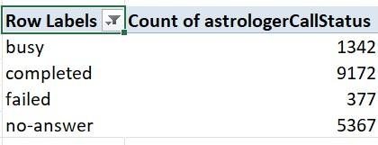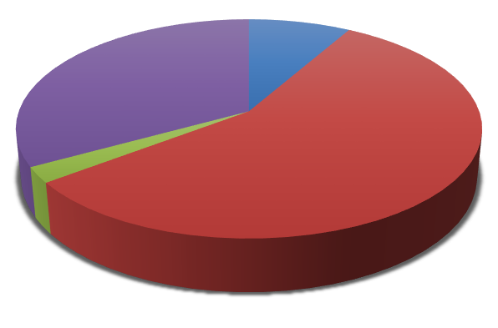

busy



8



%



completed



57



%



failed



2



%



no



-



answer



33



%



**call status**



busy



completed



failed



no

-

answer

The Given Chart shows the failure rate of calls.

1. Improved Self-Service Options

This is because customers are now able to use self-service to solve most of the questions that they have frequently. This can effectively help in cutting down on the number of calls made during peak hours self-service through IVR, chatbot or through online portals.

Action :

Integrate IVR systems to be further developed to address numerous questions which do not require the assistance of the agents.

I recommend the use of AI based chatbots to help customers solve simple problems that they come across.

The more the customers are encouraged to use self-service, the more effective they are when it comes to conveying information and providing interfaces.

Conclusion: Prioritizing targeted training, technology upgrades, enhanced call routing, workforce optimization based on historical data will lead to significant improvements in overall efficiency and customer satisfaction.

**Q6.** What can be the key factors contributing to high customer satisfaction scores, and how can these be leveraged to improve overall performance? What is the basis for the suggestions? And mention how did you decide if the satisfaction score affect the ratings?

**Answer**:

**Approach –**  for doing this question we can compare the ratings with various factors such as consultation type and website we can make a pivot table of guru and also can use dashboard to find the insights like a pivot table containing two filter consultation type

And website directly and use rating in values with max or average aggregation function And call duration in rows or astrologer call status

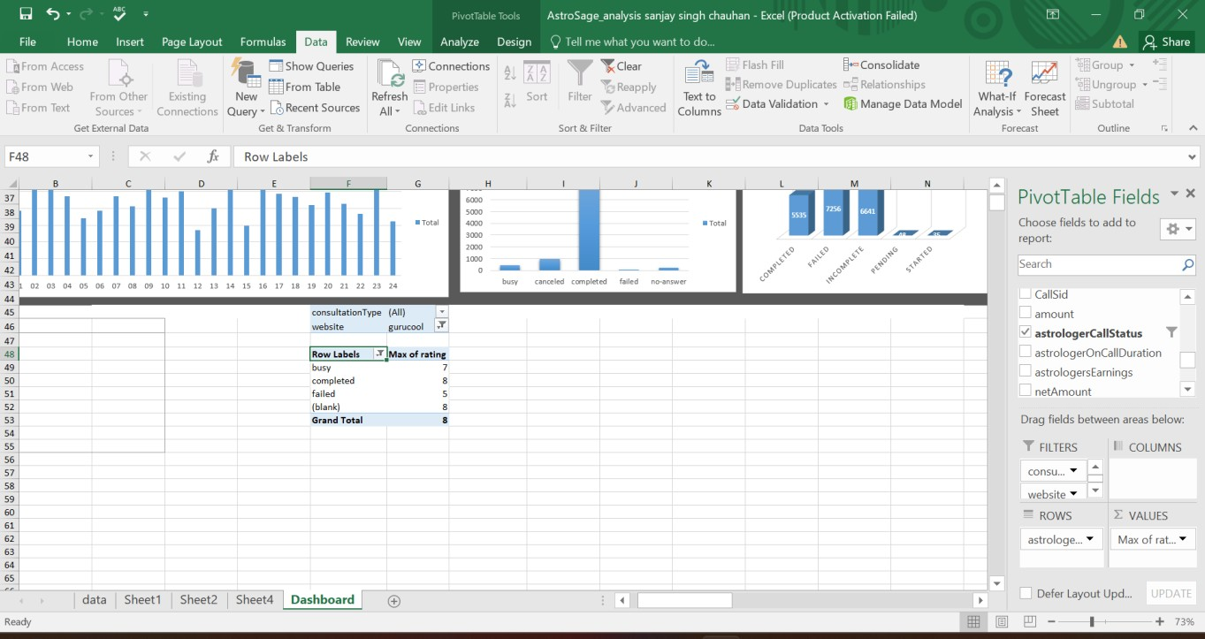

Also with user on call duration that is also showing that with increase in call duration the customer satisfaction is decreasing

**correlation**

-0.000202451

As a proper column for customer satisfaction was not available therefore considered rating as a metric to assess customer satisfaction and used that for calculation. Formula used : CORREL(Range of UserOnCallDuration, Range of Ratings)



A correlation of -0.02 suggests a very weak negative correlation between the two variables being analyzed. This means:

Rating with consultation type

0

1

2

3

4

5

6

7

8

9

0

11

20

30

42

57

90

152

177

216

246

293

311

324

357

373

427

444

491

540

592

633

694

789

1087

1630

Total

Total

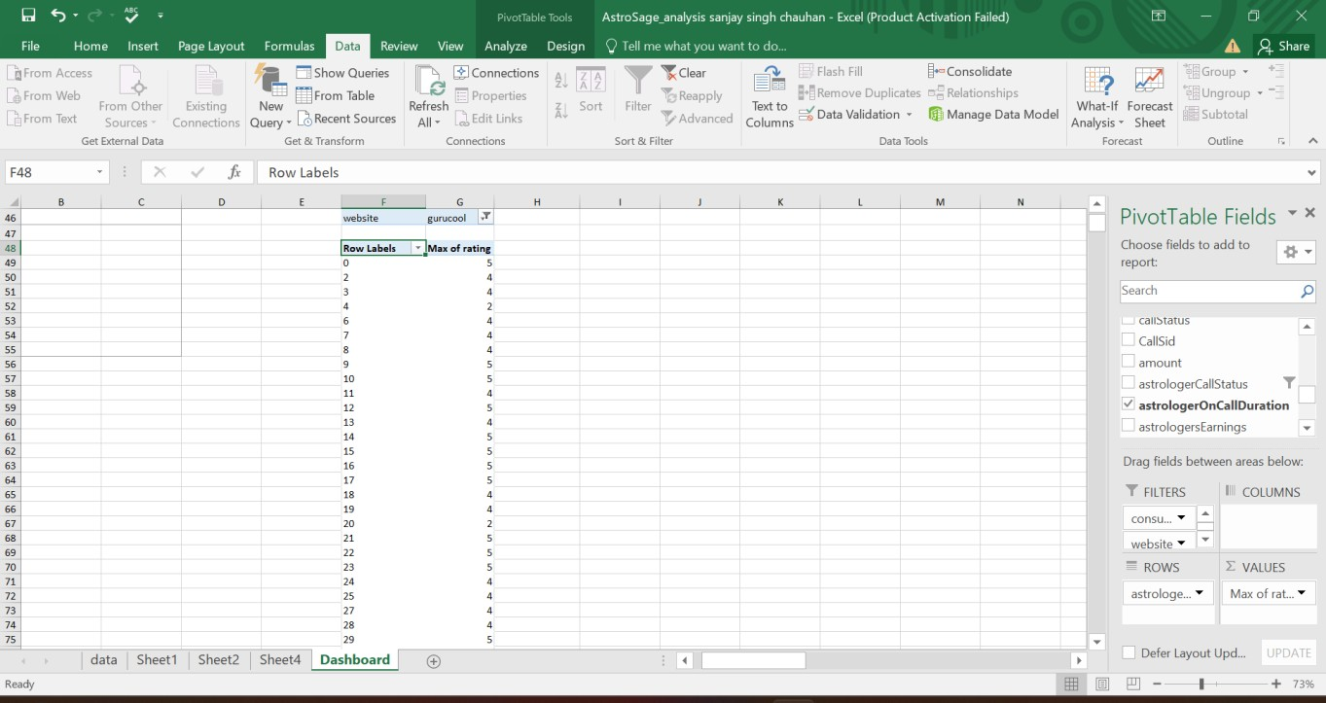

**Q7.**How should the call center balance the workload among agents to ensure optimal performance and avoid burnout?

Mention your approach and spreadsheet function for the answer?

**Answer: Approach :**  for doing this question we can compare the average call duration of each guru to identify if there is an imbalance in workload on specific gurus

For doing this we can make a pivot table that can show guru name in rows And call duration in values with aggregation function of average.

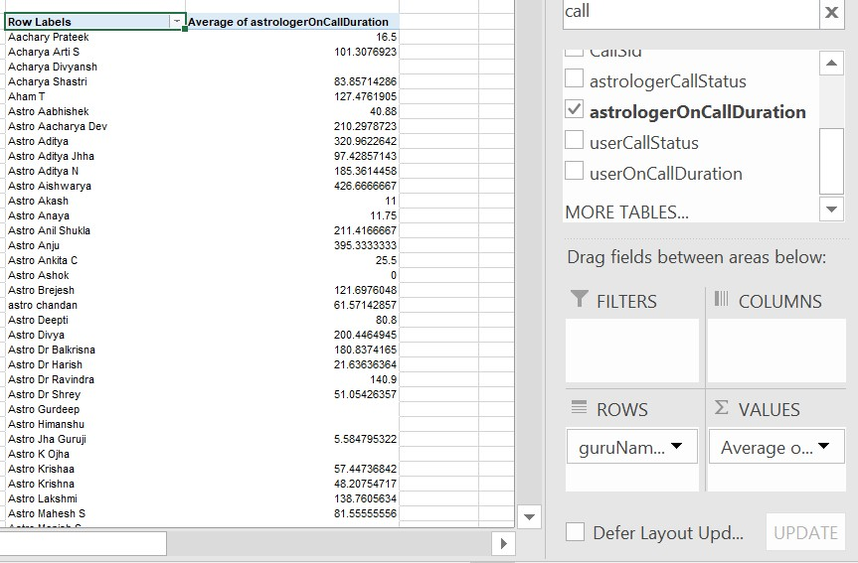

This is the pivot table present below to the dashboard.

The second column corresponds to the number of queries(both call/chat request) received by the agents.

The volume distribution among the gurus is not uniform and some of the gurus are overutilized while some are severely underutilized. This may result in overexhaustion or overburdening leading to less productivity or even gurus/agents looking for better opportunities.

Action:

* Historical call data can be analyzed to predict the peak periods and then schedule the employees accordingly. This enables the management to employ adequate personnel during the busy hours.

* One should also introduce shift work so that the agents do not always work during periods when stress levels are high. This rotation assists in ensuring that other members of the team are also involved in handling the work.

* Another change should be the use of skill-based routing, which means that calls will be directed to agents with specific knowledge of the issue. For instance, attend complex or high priority calls with agents that have a lot of experience while simple queries are handled by new or less experienced agents.

* Make available mental health services and support tools to assist the agents in dealing with pressures and stress thereby reducing instances of burnout.

* Monitor the performance of your call center in real time using tools that will help you monitor call handling time, queue lengths, and the workload of the agents. In case any particular agent is receiving a large number of calls more than others, then managers can step in to modify the distribution of the call.

**Q8.**What new technologies or tools could be implemented to enhance call center operations and customer service?

**Answer:** Improving call center management and customer relations can be done through the integration of proactive technologies and tools that facilitate management, productivity and customers’ satisfaction. Here are some new technologies and tools that can be implemented:

* 1. AI and Machine learning

AI-Powered Chatbots: Chatbots powered by artificial intelligence can attend to simple inquiries and customer relations hence lowering call traffic for agents. NLP based chatbots can give appropriate responses like a human and can solve most of the problems without involving a human.

Tool Examples: IBM Watson, Google dialog flow, zendesk answer bot.

* 1. Robotic Process Automation (RPA)

Task Automation: Some of the activities that could be automated include data input, updating customer databases, and processing of refund. This relieves agents from simple tasks allowing them to manage complicated interactions hence enhancing the efficiency of the services.

Tool Examples: UiPath, Automation Anywhere, Blue Prism are some of the famous companies that provide RPA.

* 1. Cloud-Based Call Center Solutions

Scalability and Flexibility: Cloud-based call center platforms provide flexibility in that they can be easily customized to provide for growth. These platforms also support remote work, which enhances flexibility in staffing and business operation even in an event of disruption.

Tool Examples: Hence, other telephony solutions such as Amazon Connect, Twilio Flex, and RingCentral.

* 1. This section focuses on how Customer Relationship Management (CRM) Integration takes place in the company.

360-Degree Customer View: The integration of the call center with a CRM system helps the agents to work with all the information regarding the customer’s past interactions, orders, and preferences. It results in more appropriate service delivery since clients are treated individually as they are.

Tool Examples: Some of the popular CRM systems include, Salesforce, HubSpot CRM, Microsoft Dynamics 365.

**Q9.**What metrics should be included in the final dashboard to provide a comprehensive view of call center performance and guide investment decisions?

**Answer:**

Metrics that can be included in the final dashboard to optimize the business and identify any underlying issues can be:

Filters:

1. Consultation Type Filter
2. Platform Filter(website or app)

Metrics on which these filters act upon are:

* Total Revenue Generated: This shows the total revenue of the business from all of its activities. This can be filtered out to gauge the income from different consultation types(call, chat or both) as well as from different platforms(app, website or both). It is an important metric to gauge the overall performance.
* Total active gurus/agents: Another important metric that measures the workforce available to serve the customers. This can also be filtered through the provided filter options.
* Daily Active Users: This visualizes the daily activity of users on different platforms(app, gurucool,etc.). It can be an important metric to measure the number of users coming to the business daily. It can give an overview of the performance of business and any changes occuring.
* Daily activity on Astrosage: This chart visualizes the trend of overall daily activity on the Platform(all) and can be filtered via the available filters to view the specifics of the business.
* Activity v/s Revenue: It gives an overview of the total activity and the revenue generated by different consultation types(eg. Call, chat,etc). It can be used to analyze the income from activity of users of different consultation preferences and the revenue/income generated from them.
* One Time v/s Repeat Users: this is an important chart that can show the repeat user percentage. For any business, repeat user analysis is important as one cannot survive only on new users.
* Platform Activity Overview: This gives the percentage distribution of the activity on various consultation preferences(chat, call,etc.). It gives an overview of the type of consultation preferred by the users.
* Average Rating Distribution: This is a very important metric that shows the health and performance of the business. It gives an overview of whether the customer is liking the service provided or not. Based on this, important changes can be included in order to improve the overall customer experience.

**Q10.**How would you allocate a 1 crore rupee investment to optimize operational efficiency, enhance customer satisfaction, and boost profitability, and what analysis-based recommendations would you offer to support this? [you have to give bullet pointers in order to answer this question] **Answer:**  **1. Technology Upgrades (Rs.40 lakhs )**

Recommendation:Invest in advanced call distribution systems, AI driven chatbots and CRM tools.

* Rationale:

During peak hours technology upgrades will provide for efficient call routing, balancing agent workloads and decreasing the wait times for customers.

With an AI based tool, agents can handle more complex cases and AI tools are able to handle routine questions.

Integrating technology into your CRM will improve tracking and provide better, personalized customer service.

* Expected Impact:

Operational Efficiency: Improved response times and reduced agent burnout. Profitability: Handling calls and chats more efficiently and thereby increasing revenue.

**2. Training Programs (25 lakhs)**

Recommendation: Targeted training in communication, problem-solving, product knowledge and so on. ● Rationale:

Chats generate high customer engagement but have low revenue so there is a need to improve the conversion focus of our communication.

Agents will be upskilled to handle complex queries which will reduce resolution time and provide happier customers.

* Expected Impact:

Customer Satisfaction: Better measured interactions = higher quality interactions = better ratings = repeat customers.

Profitability: Improved upsell and cross selling during customer interaction. **3. Additional Agents (20 lakhs)**

Recommendation: Increase agents so that there’s no baggage or queueing slack during peak times. ● Rationale:

Existing agents are overwhelmed during the peak times resulting in long customer wait times and customer dissatisfaction.

New agents will help balance workloads and make sure customers don't have to wait for help.

* Expected Impact:

Operational Efficiency: Increased average call/chat waiting times.

Customer Satisfaction: Reduced wait times to allow for a more improved experience with faster query resolution.

**4. Customer Retention strategies/Marketing (15 lakhs)**:

Recommendation: This will allow you to put money aside for Customer Retention Programs (such as loyalty points, or improve based on Customer Feedback), as well as marketing.

* Rationale:

Tailored loyalty programs can help boost customer satisfaction, according to data.

* Expected Impact:

Customer Satisfaction: But personalization through personal offers and the feedback to improve the same.

Profitability: Retaining customers leads to consistent revenue with lower acquisition costs.